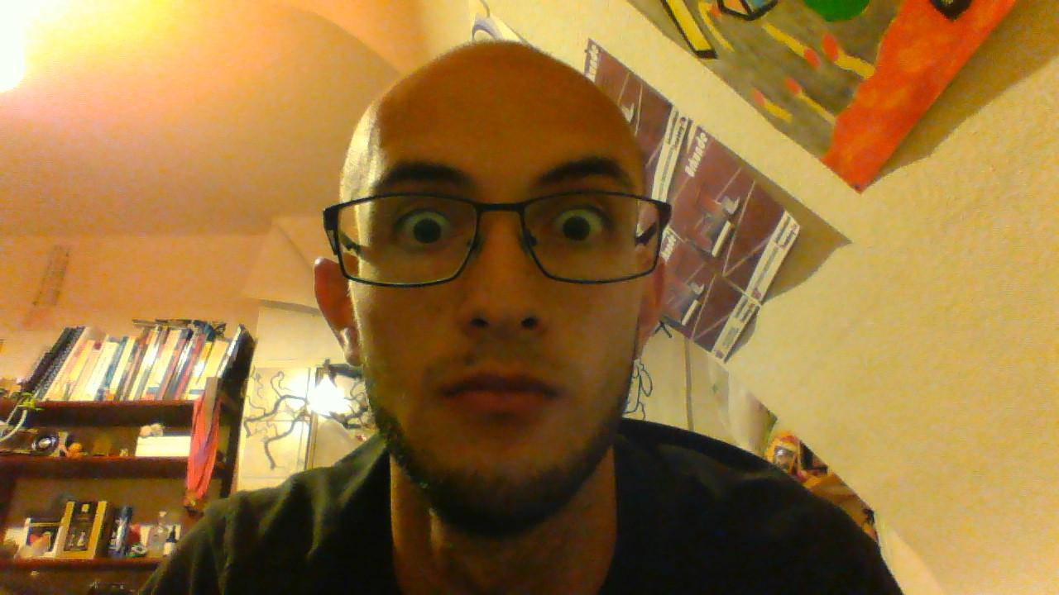

from google.colab import drive

drive.mount('/content/gdrive')

import numpy as np

import cv2

from google.colab.patches import cv2_imshow

face_cascade = cv2.CascadeClassifier("/content/gdrive/My Drive/Colab Notebooks/haarcascade_frontalface_default.xml")

eye_cascade = cv2.CascadeClassifier("/content/gdrive/My Drive/Colab Notebooks/haarcascade_eye.xml")

img = cv2.imread("/content/gdrive/My Drive/Colab Notebooks/bild.jpg")

#cv2_imshow(img)

gray = cv2.cvtColor(img, cv2.COLOR_BGR2GRAY)

faces = face_cascade.detectMultiScale(gray, 1.3, 5)

for (x,y,w,h) in faces:

cv2.rectangle(img,(x,y),(x+w,y+h),(255,0,0),2)

roi_gray = gray[y:y+h, x:x+w]

roi_color = img[y:y+h, x:x+w]

cv2_imshow(img)

cv2.waitKey(0)

cv2.destroyAllWindows()

